Reference Link : <http://supervisord.org/installing.html#installing-a-distribution-package>

Downlaod required distributions given below. Setuptools may not require if you already have it.

* setuptools (latest) from <http://pypi.python.org/pypi/setuptools>.
* meld3 (latest) from <http://www.plope.com/software/meld3/>.
* elementtree (latest) from <http://effbot.org/downloads#elementtree>.

Copy downloaded zip files to desired location on the machine without internet connectivity.

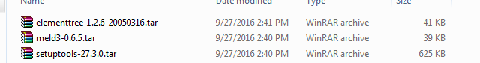

Extract to certain directory

Go to individual extracted directory and execute command **python setup.py install** in each directory.

* Download supervisord distribution package from Supervisord package https://pypi.python.org/pypi/supervisor

Upload the zip file to required machine. Extract it to the desired directory.

Go to extracted directory and execute command python **setup.py install**

**Creation of configuration file:**

Then refer instruction given at<http://supervisord.org/installing.html#creating-a-configuration-file>